US History- Unit 6: WWII
Journal Prompts:
Journal 17: How could normal Germans let the Holocaust happen?
Journal 18: 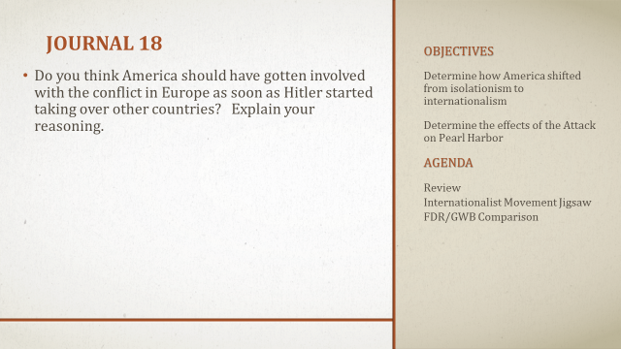
Journal 19: 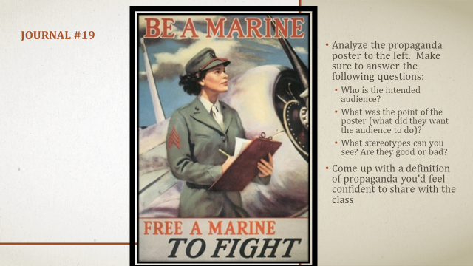
No Journal 20- Pop Quiz
Journal 21: 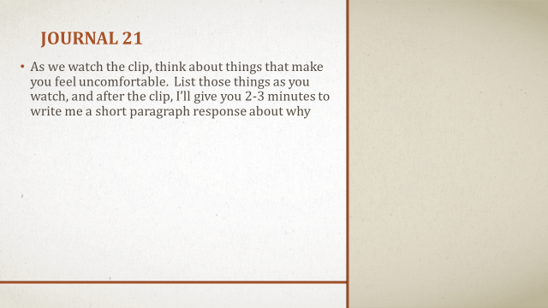
Journal 22: 