RUMAN DOCTRINE CARTOON. 
'Where To?' American cartoon comment, 1947, on President Truman's request for $400 million from Congress to defend the vulnerable countries of Greece and Turkey from Communist pressure, a policy which came to be known as the 'Truman Doctrine.'

1

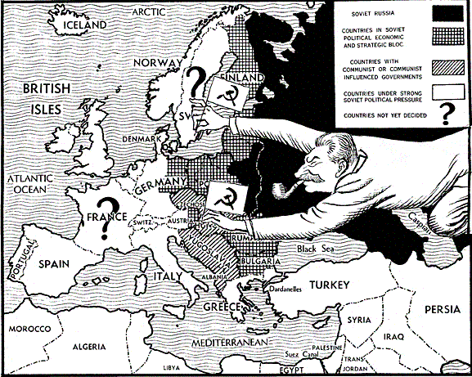

2

3

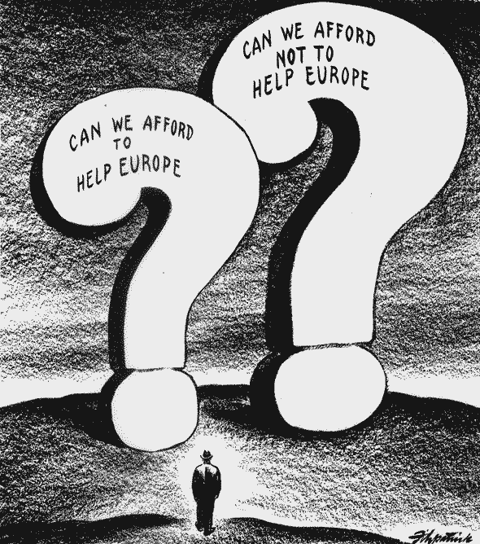

4

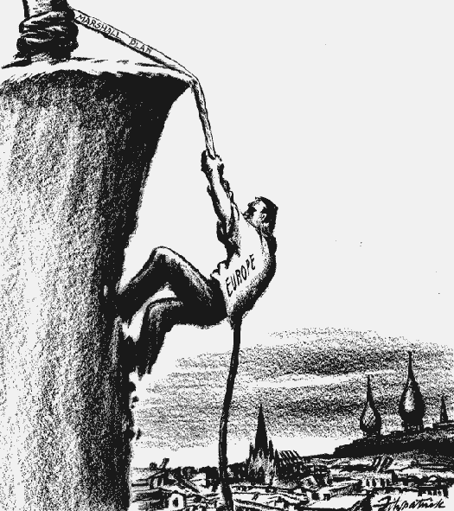

5

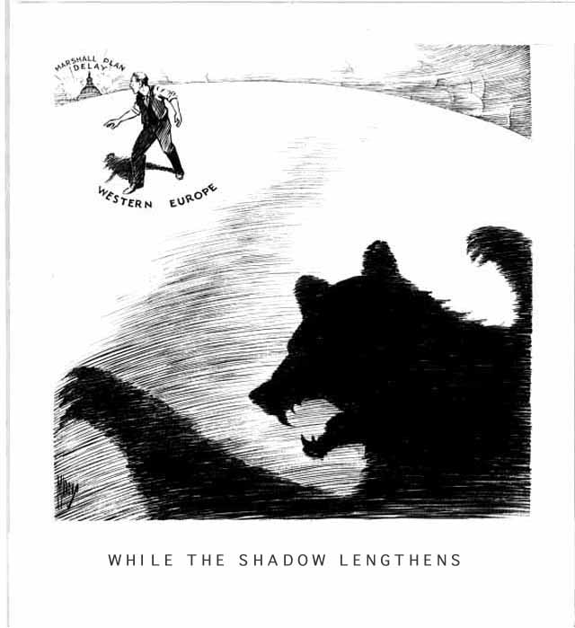

6

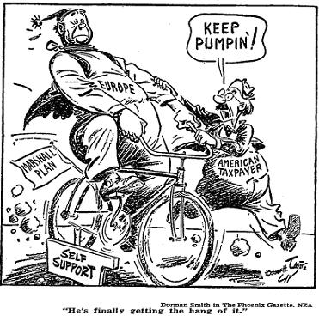

7

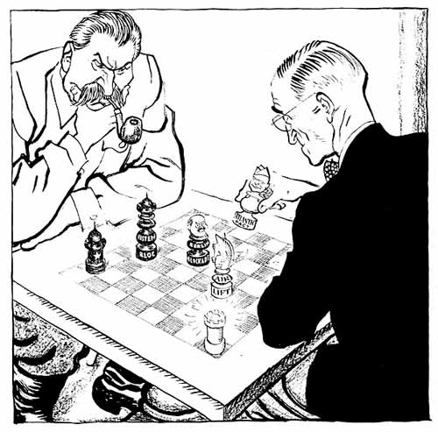

8

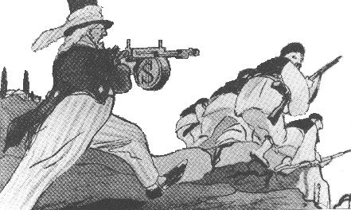

9

