The Roaring 20’s Presentation
www.afhsmorris.weebly.com
Unit 4: The Roaring Twenties/Jazz Age
PRESENTATION REQUIREMENTS

PRESENTATION DATES:

A DAY - Friday, November 21st
A DAY - Tuesday, November 25th

GROUP PRESENATION REQUIREMENTS:

Your presentation must be at least 8 minutes and no more than 12 minutes long.
Your presentation consists of three different parts, which include:

- Teaching (5 min) – presentation of information, you can use PowerPoint, give the information verbally with posters or pictures to pass around, or use another method. If you use PowerPoint, do not think you may simply read the information to us off of your slides. You need to make this presentation interesting as well as informational. You need to focus your presentation on the following:
  - Basic background of your topic (include pictures)
  - What impact your topic has on American history?

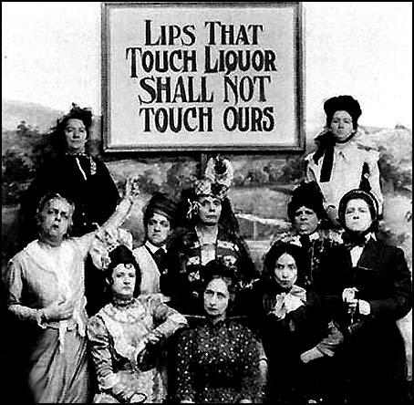
- Creative Presentation (2 min) – this can include a skit, a video, music, or some other idea you approve with me. Make sure that it is relevant to your topic, as well as fun and entertaining for the class.

- Reinforcement of Information (3 min) – you may use a class discussion, a game, a quiz, etc.

Other Requirements:
- During presentations, the audience will be required to take notes. At the end of your presentation, include a slide that shares the five (5) most important aspects that students need to take away from your presentation. Remember, YOU are responsible for what the class learns.
- You must provide a Works Cited Page that lists all the resources you used to gather information.
- Each person from your group needs to be equally involved in both the planning and presenting.

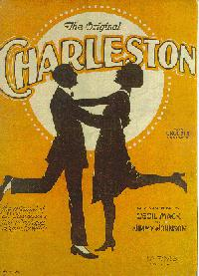
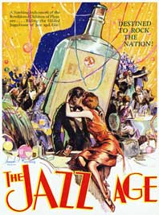
During this class period and the next, you will be able to work on your project, however, if you do not finish in class, you will need to meet outside of class to complete all of the requirements. As you prepare for your project, make sure you practice giving your presentation. You will be graded on how well you present the information as well as what information you present.

